
CC-215-L: Database Systems Lab

Faculty of Computing & Information Technology

BS(IT/CS) Morning - Fall 2023
LAB – 04(ODD)

The objective of this lab is to:
- Group Functions
- Analytical Functions
- Equi joins
Course & Lab Instructor: Dr. Asif Sohail
LAB TIMING : 90 MINS
TOTAL MARKS : 40
Task 01: [15 marks]
- Display the jobs with the total number of hirings.
SELECT JOB ,COUNT(*)AS "TOTAL HIRING"
FROM EMP
GROUP BY JOB
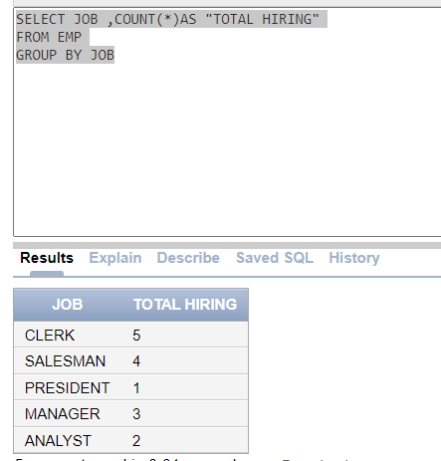
- Display the following output.
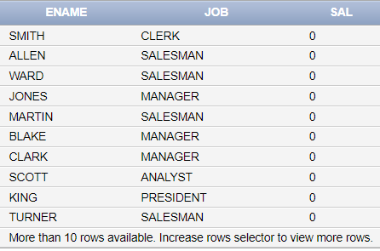
SELECT ENAME,JOB,MIN(SAL) OVER() AS "SAL" FROM EMP
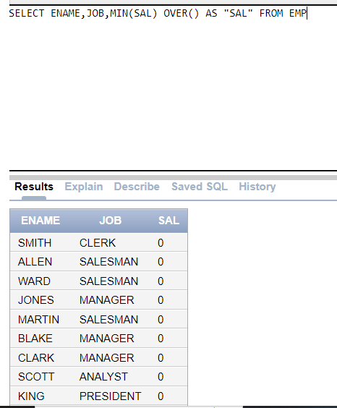

- Display the DNAME,Ename,Job and salary of the employees working as a clerk
SELECT DNAME,ENAME,JOB,SAL
FROM EMP e
JOIN DEPT d
ON E.DEPTNO = D.DEPTNO
WHERE JOB = 'CLERK'
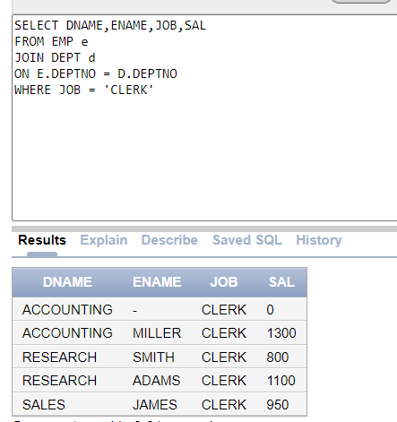

- Write an SQL query to display how many employees are working in Dallas
SELECT LOC , COUNT(E.EMPNO)
FROM EMP e
JOIN DEPT d
ON e.DEPTNO = d.DEPTNO
WHERE LOC = 'DALLAS'
GROUP BY LOC
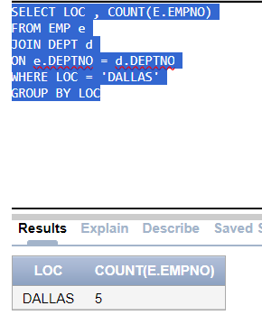
- Display the average salary for each deptno, including only those grades where the average salary exceeds 1500. The output should display the salary grade and the corresponding average salary.
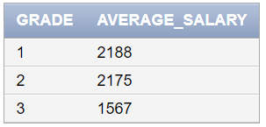
WITH EMP_GRADE AS
(SELECT DEPTNO, AVG(SAL) AVG_SAL
FROM EMP
GROUP BY DEPTNO
HAVING AVG(SAL)>1500)
SELECT RANK() OVER(ORDER BY AVG_SAL DESC) GRADE, ROUND(AVG_SAL) AVERAGE_SALARY FROM EMP_GRADE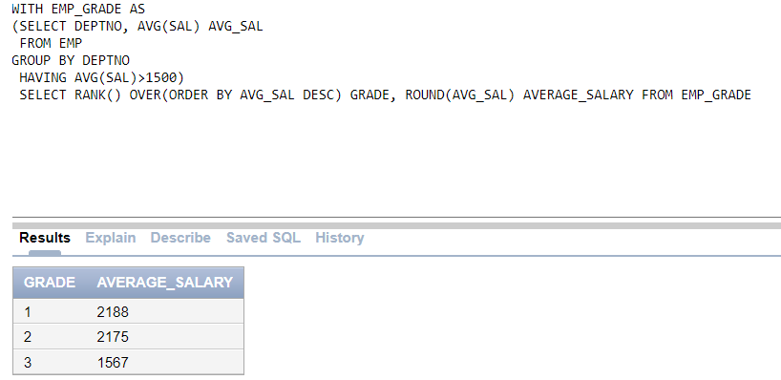
- Display the following output
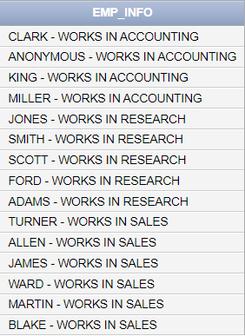
SELECT NVL(ENAME,'ANONYMOUS') || ' - WORKS IN '|| DNAME
FROM EMP e
JOIN DEPT d
ON e.DEPTNO=d.DEPTNO
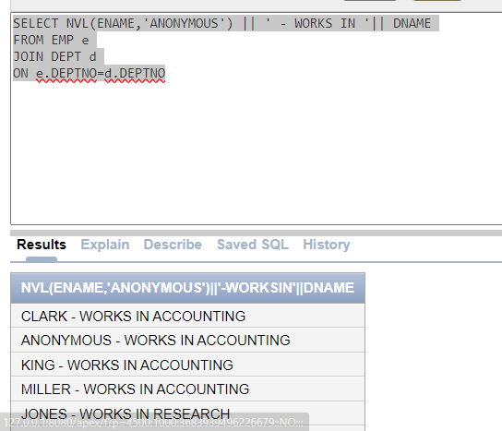
- Find out the number of employees under each manager (DON’T USE JOINS)
SELECT mgr, COUNT(*) AS "EMP-COUNT"
FROM emp
GROUP BY mgr;
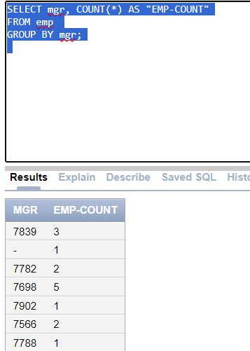
8. List the jobs in all the departments as follows.
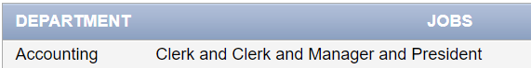
SELECT INITCAP(DNAME) AS DEPARTMENTS, LISTAGG(INITCAP(JOB),' and ') WITHIN GROUP (ORDER BY JOB) AS JOBS
FROM EMP e
JOIN DEPT d
ON e.DEPTNO = d.DEPTNO
GROUP BY DNAME
ORDER BY DNAME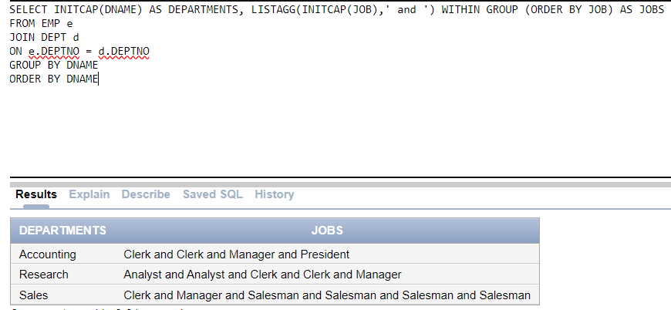

Task 02: [20 marks]
- Write an SQL query to display the names of all departments having no employees
SELECT D.DNAME, COUNT(E.EMPNO)
FROM EMP E
RIGHT JOIN DEPT D
ON E.DEPTNO = D.DEPTNO
GROUP BY D.DNAME
HAVING COUNT(E.EMPNO) = 0
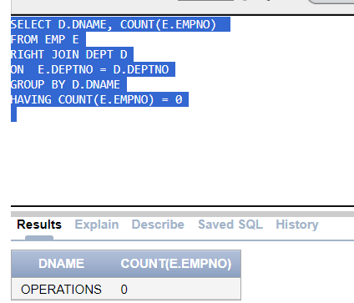
- Summarize a report that displays each job along with all the associated departments and the total salary earned for each job. Additionally, provide the reverse view showing all departments along with their respective jobs and the total salary earned in each department.
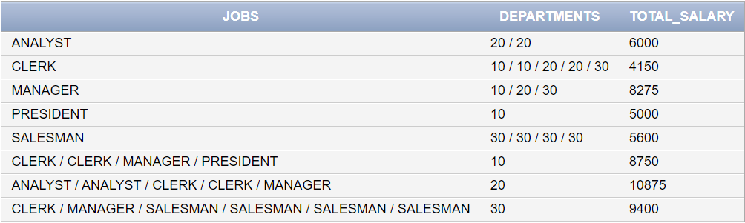

SELECT NVL(JOB,LISTAGG(JOB,'/')WITHIN GROUP (ORDER BY JOB)) AS JOBS ,NVL(TO_CHAR(DEPTNO),LISTAGG(DEPTNO,'/') WITHIN GROUP (ORDER BY DEPTNO)) AS DEPARTMENTS,
SUM(SAL) AS "TOTAL SAL"
FROM EMP
GROUP BY GROUPING SETS (JOB,DEPTNO)
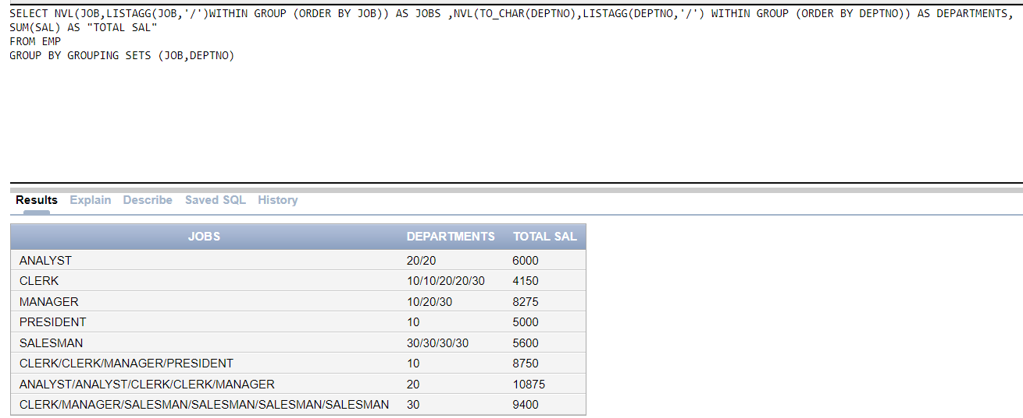
- Write an SQL query to display the following output. (DON’T USE JOINS)

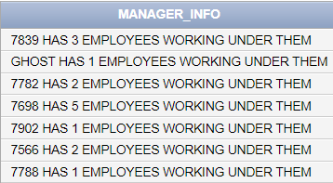
SELECT NVL(TO_CHAR(MGR),'GHOST') || ' HAS ' || COUNT (*) || ' EMPLOYEES WORKING UNDER THEM' AS "MANAGER INFO"
FROM EMP
GROUP BY MGR
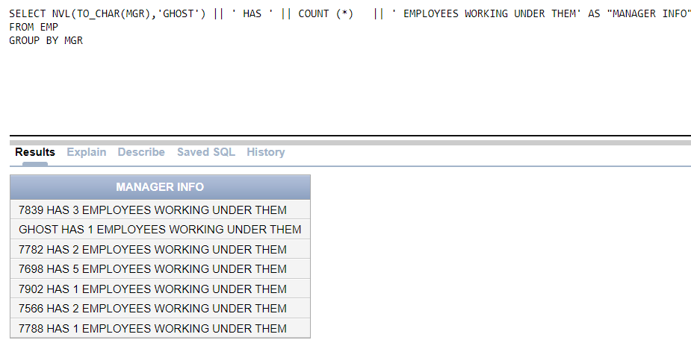
- List down the employees having the same manager. Use ANALYTICAL FUNCTIONS…..
SELECT MGR, LISTAGG(ENAME,',')
WITHIN GROUP(ORDER BY MGR)AS EMPLOYEES
FROM EMP
WHERE MGR IS NOT NULL
GROUP BY MGR
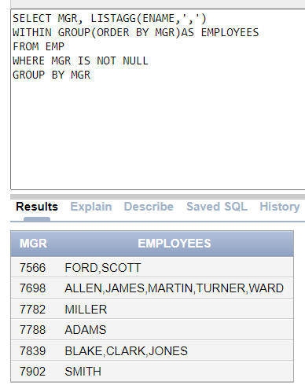
- Display the amount remaining of each department after paying all expenses [The total salaries of all employees of that department]. The department no 10,20 receives 15,000. The department no 20,40 receives 17,000.
SELECT DNAME,
CASE
WHEN e.DEPTNO IN (10,20) THEN (SUM(SAL)+COUNT(SAL)*15000)-SUM(SAL)
WHEN e.DEPTNO IN (30,40) THEN (SUM(SAL)+COUNT(SAL)*17000)-SUM(SAL)
ELSE 0
END AS SAL_AFTER_EXPENSES
FROM EMP e
JOIN DEPT d
ON e.DEPTNO = d.DEPTNO
GROUP BY DNAME,e.DEPTNO
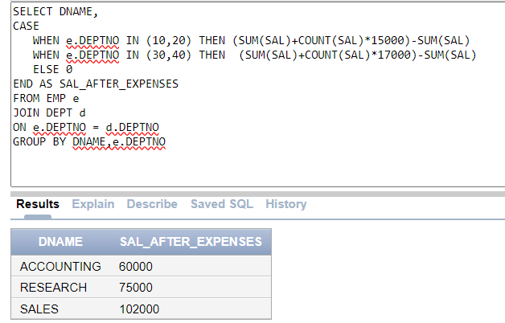
- List employees hired after 1980, categorized by whether they earn a commission. The query should return only 2 ROWS in return.

SELECT
CASE
WHEN COMM IS NOT NULL THEN 'WITH COMM'
ELSE 'NO COMM'
END AS COMM,
LISTAGG(ENAME,',')WITHIN GROUP(ORDER BY HIREDATE) AS EMPLOYEES
FROM EMP
WHERE EXTRACT (YEAR FROM HIREDATE)>1980
GROUP BY
CASE
WHEN COMM IS NOT NULL THEN 'WITH COMM'
ELSE 'NO COMM'
END ;
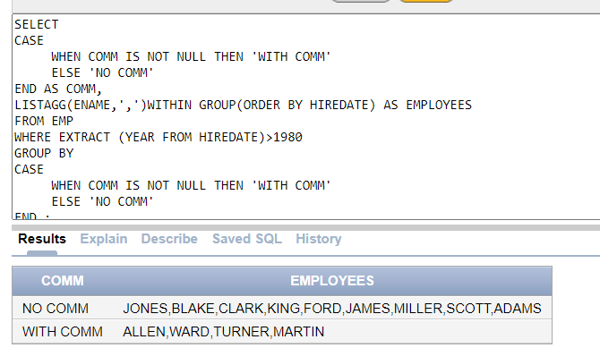

- Display the employee names (ename), department numbers (deptno), department locations (dept location), and job titles (job) in ascending order of job titles for those employees whose joining month in December.
SELECT ename, D.deptno, loc, job
FROM EMP e
JOIN dept d
ON e.DEPTNO = d.DEPTNO
WHERE EXTRACT(MONTH FROM hiredate) = 12
ORDER BY job
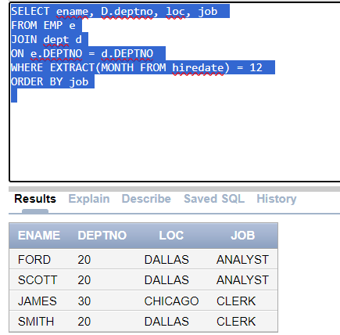
8. We want to assign a special code for each employee in emp table based on its salary. The sal is rounded it to its nearest thousand value. The special code is assigned on the basis of the following rules:
a. A for 1000
b. B for 2000
c. C for 3000
d. D for 4000
e. E for 5000
f. S for 0
Note: You are not allowed to use decode or case for this question.

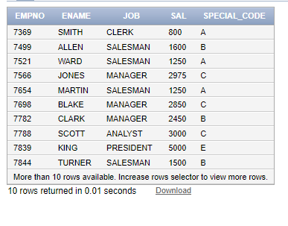

SELECT EMPNO,ENAME,JOB,SAL,TRANSLATE(DENSE_RANK() OVER(ORDER BY ROUND(SAL,-3)),'123456','SABCEF')
FROM EMP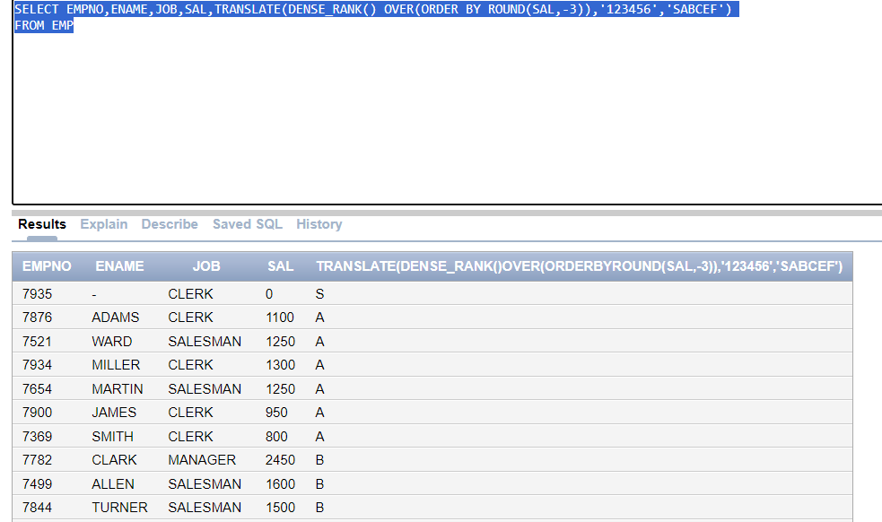
Task 03: [5 marks]
1. Write a query that calculates the total salary grouped by department (deptno) or job. If the department or job is NULL, display "All Depts" or "All Jobs" instead.
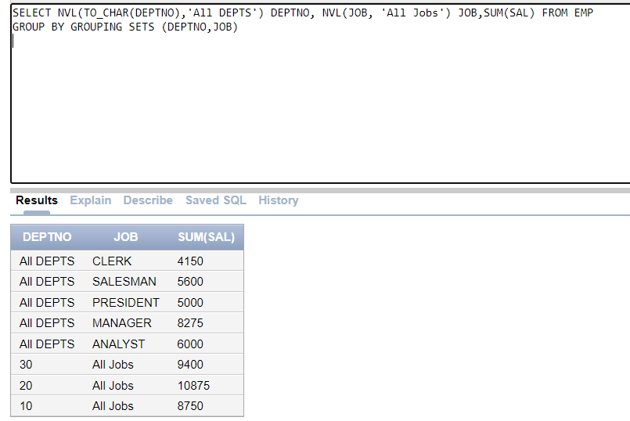

2. Display the employee names (ename), department numbers (deptno), department locations (dept location), and job titles (job) in ascending order of job titles for those employees who joined after the First half of 1981
SELECT e.ENAME, e.DEPTNO, LOC, e.JOB, e.HIREDATE
FROM EMP e
JOIN DEPT d
ON e.DEPTNO = d.DEPTNO
WHERE EXTRACT(YEAR FROM e.HIREDATE) = 1981
AND EXTRACT (MONTH FROM e.HIREDATE) > 6
ORDER BY e.JOB ASC
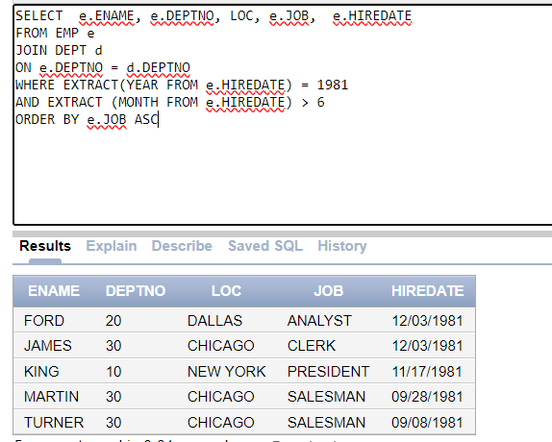

Task 04: [5 marks]
VIVA VOCE

